# horizontal lineData Structures

Homework Assignment 7 - Binary Search Tree

Problem 1 – Longest Distance - 25 Points

Problem 2 – Lowest Common Ancestor - 25 Points

Problem 3 – Kth Largest Element - 25 Points

Problem 4 – Same Tree - 25 Points

**Notes and Requirements**

* Your submission must be your effort. You can not copy other students' code.
* This worksheet is graded on performance; Implementations must be correct.
* You are encouraged to visit our office hours to ask coding questions.
* Only the latest (most recent) submission is graded.
* Late submissions are not considered for grading.
* You can not use any third-party libraries.

**Some assignments on this worksheet are manually graded.**

## Problem 1 – Longest Distance - 25 Points

Implement the member diameter(self), which returns the maximum distance between two nodes. The distance between two nodes can be defined as the following function in which LCA is the Lowest common ancestor of *node1* and *node2*: *diameter = depth(node1) + depth(node2) −2 ∗ depth(LCA)*

The longest distance between two nodes (diameter) in the following Binary Search Tree is 8. The nodes of the longest path in this example are the nodes with elements 2 and 12. The lowest common ancestor of these nodes is the node with element 6.

**Example**

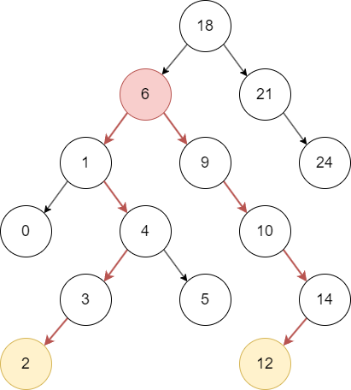

**Requirements**

* The time complexity requirement of this method is at most **O(n^2)**.
* The space complexity requirement of this method is at most **O(n)**.
* You cannot use Python lists or any other built-in data structures.
* You can not change the provided Binary Search Tree.

**Important**

* You can expect that each tree has only one longest path.
* You can expect that given trees have at least one node.

## Problem 2 – Lowest Common Ancestor - 25 Points

Implement the member lca(self, node1, node2), which returns the node of the lowest common ancestor of the given nodes *node1* and *node2*.

**Example**

|  | lca(node_6, node_9) → node_7  lca(node_6, node_7) → node_7  lca(node_3, node_20) → node_10  lca(node_3, node_15) → node_10 |
| --- | --- |
|  |  |

**Requirements**

* The time complexity requirement of this method is at most **O(n)**.
* The space complexity requirement of this method is at most **O(1)**.
* You cannot use Python lists or any other built-in data structures.
* Your function has to return a tree node, not a node’s element.

**Important**

* You can expect that given trees have at least one node.
* You can define any helper functions.

## Problem 3 – Kth Largest Element - 25 Points

Implement the memberkth_largest(self, k), which returns the kth largest element in a Binary Search Tree. If k is too large, return the smallest element’s node within the tree. If k is too small, return the largest element’s node in the tree.

**Example**

|  |  |
| --- | --- |
| |  | kth_largest(1) → node_20  kth_largest(3) → node_10 | | --- | --- | |  |  | | |

**Requirements**

* The time complexity requirement of this method is **O(n log n)**.
* The space complexity requirement of this method is **O(n)**.
* Your function has to return a tree node, not a node’s element.
* You cannot use Python lists or any other built-in data structures.

## Problem 4 – Same Tree - 25 Points

Implement the member function same(self, i1, i2), which verifies whether two sets of keys build the same binary search tree without building a binary search tree. Return *True* if both sets describe the same tree. Return *False* otherwise.

**Example**

| *# Find this tree on the right*  *i1 = [15,25,20,22,30,18,10,8,9,12,6]*  *i2 = [15,10,12,8,25,30,6,20,18,9,22]*  *res = Solution().same(i1,i2)*  *print(res) # Should print true* |  |
| --- | --- |

**Requirements**

* The time complexity requirement of this method is at most **O(n^2)**.
* The space complexity requirement of this method is at most **O(n^2)**.